**LAB REPORT NO 12**



Submitted by:  **Muhammad Ali**

Registration No: - **19PWCSE1801**

Class Section: A

“On my honor, as student of University of Engineering and Technology, I have neither given nor received unauthorized assistance on this academic work.”

Submitted to:

**Engr. Durr-e-Nayab**

Data:(13,08,2021)

Department of Computer Systems Engineering

University of Engineering and Technology, Peshawar

**Signal and system 1: -**

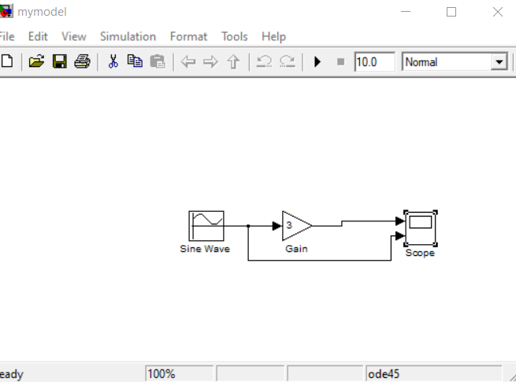

**Scope Signal and system 1: -**

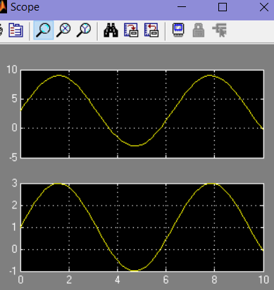

**Signal and system 2: -**

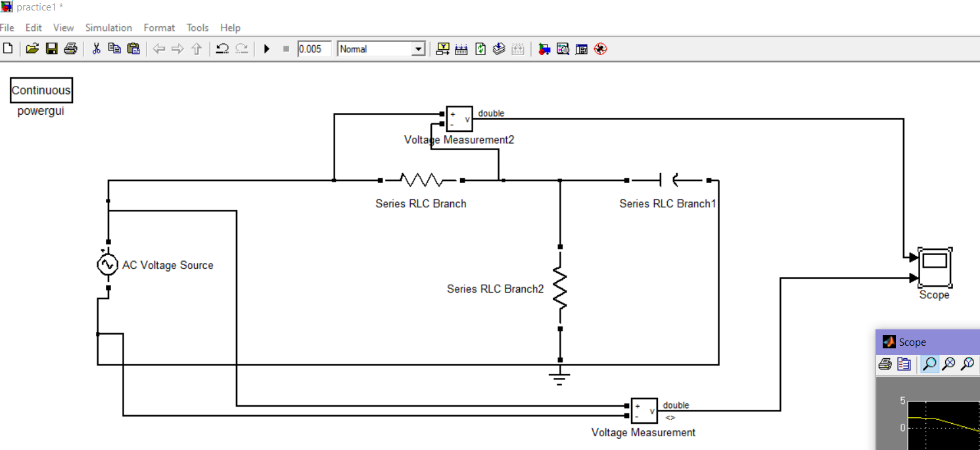

**Scope Signal and system 2: -**

